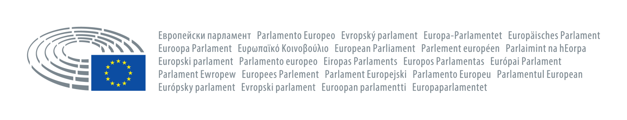

**The justified demands of Özak Tekstil employees must be met**

For days, hundreds of workers at the textile company Özak Tekstil in Urfa/Turkey have been protesting for the withdrawal of their colleague's dismissal, better working conditions and recognition of their union election.

The difficult working conditions at Özak Textil have been known for years. These range from threats, insults and harassment to forced overtime. The management of Özak Tekstil not only violates Turkish labour law, but also ILO standards.

After more and more workers left the trade union Öz Iplik-Is, which is affiliated to the HAK-IS confederation, and joined the independent, militant trade union BIRTEK-SEN, they were repeatedly threatened and attacked by the management. Öz Iplik-Is also stood idly by and watched this behaviour of the management and, according to reports from the workers, even approved of it. The pressure went so far that individual workers were forced to resign from BIRTEK-SEN with threats and intimidation and rejoin Öz Iplik-Is. After one worker was pressurised to resign from BIRTEK-SEN and resisted, she was dismissed, whereupon hundreds of workers stopped work against this dismissal and started a sit-in in front of the factory.

After four days of strike action, the governorate of Urfa also intervened in the labour dispute and attacked the strikers with gendarmerie units, had the chairman of BIRTEK-SEN, Mehmet Türkmen, temporarily arrested and banned actions and demonstrations in the city. The management of Özak Tekstil is not only using the help of the security forces, but also, as it became known today, the courts by charging the workers!

Despite all this, the workers continue to fight and stand behind their demands:

To take back the dismissals.

To stop the threats and pressure on union members.

To recognise BIRTEK-SEN as their representative.

Özak Tekstil is a company that claims to work with over 25 global brands and exports its goods to over 30 countries. The majority of these brands are based in Europe, such as ZARA, Marc O'Polo, Massimo Dutti, Hugo Boss, or global brands such as Levis and Mustang, which also operate in Europe. It is unacceptable for these companies to work with a company that clearly disregards the fundamental rights of its employees! It must also be a fundamental concern of these global companies that the ILO standards are observed by their partners.

Recognising that strengthening democracy requires the respect and promotion of social rights and freedoms, we, as Members of the European Parliament, stand in solidarity with the struggle of Özak Tekstil workers and support their demands.

**Özlem Alev Demirel** (The Left)

**Nikolaj Villumsen** (The Left)

**Dietmar Köster** (S&D)

**Giorgos Georgiou** (The Left)

**Manu Pineda** (The Left)

**Cornelia Ernst** (The Left)

**Miguel Crespo Urban** (The Left)

**Eugenia Palop Rodriguez** (The Left)

**Clare Daly** (The Left)

**Mounir Satouri** (Verts/Ale)

**Marisa Matias** (The Left)

**Josè Gusmào** (The Left)

Brussels, 07 December 2023